PROJECT SUMMARY

petOnly enterprise is a platform bringing together pet Owner and services for pets.

Owner can see users in the system and requests of the users.

Pet owner add pets to the system and add requests for pet walking, pet grooming and so on.

Used Technologies:

Angular.js

HTML5

CSS

AJAX

Bootstrap

JSON

XML

SCREENSHOTS AND THINGS I HAVE DONE

Homepage.

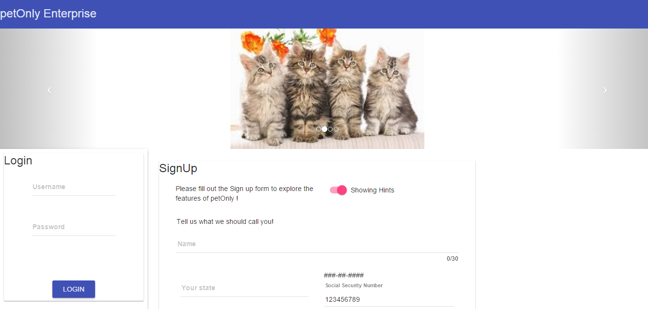

Sign up form with autosuggest

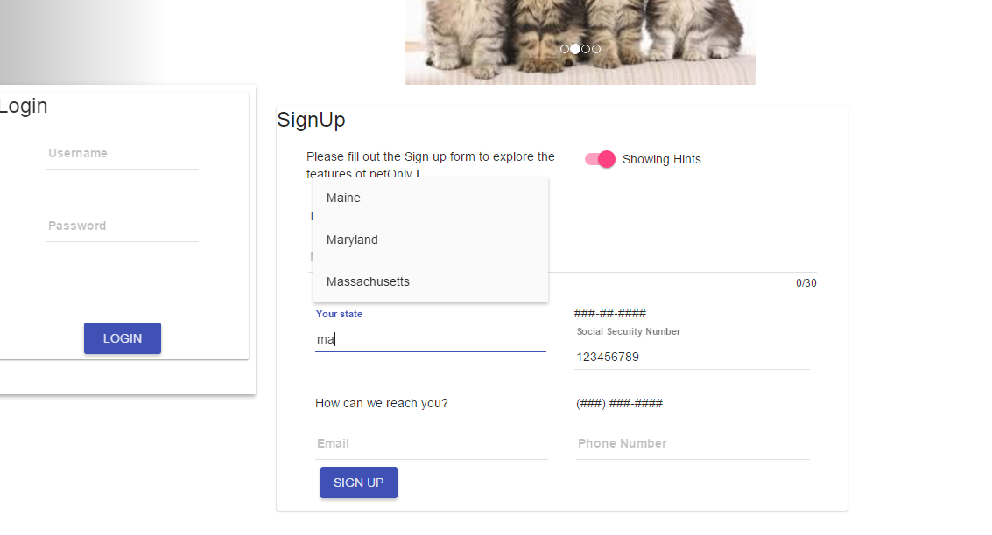

Validations on Sign up Form

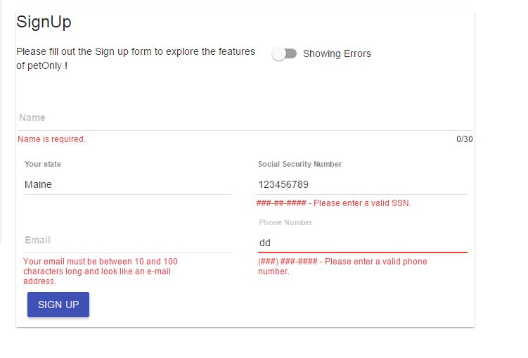

Admin Login

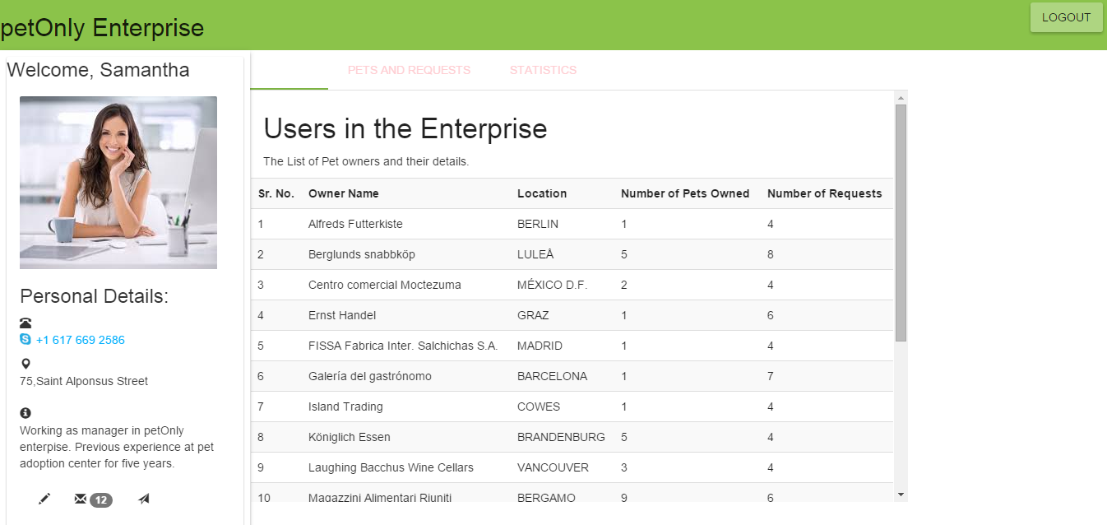

Graph by d3.js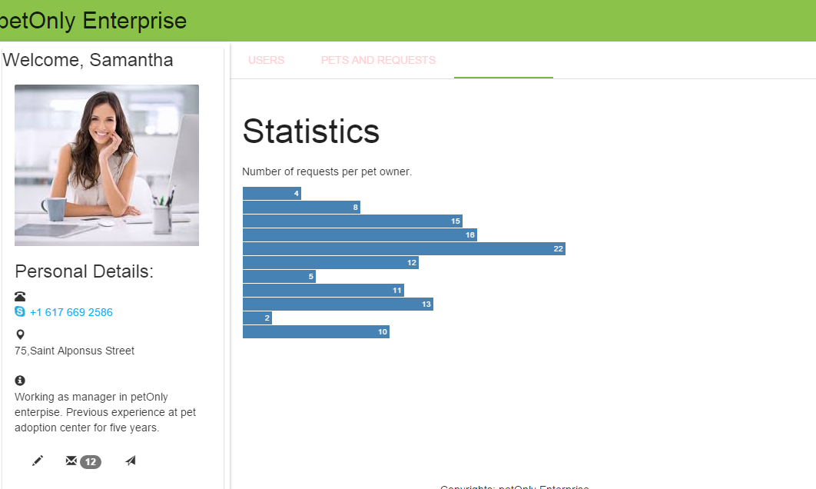

Requests table by AJAX

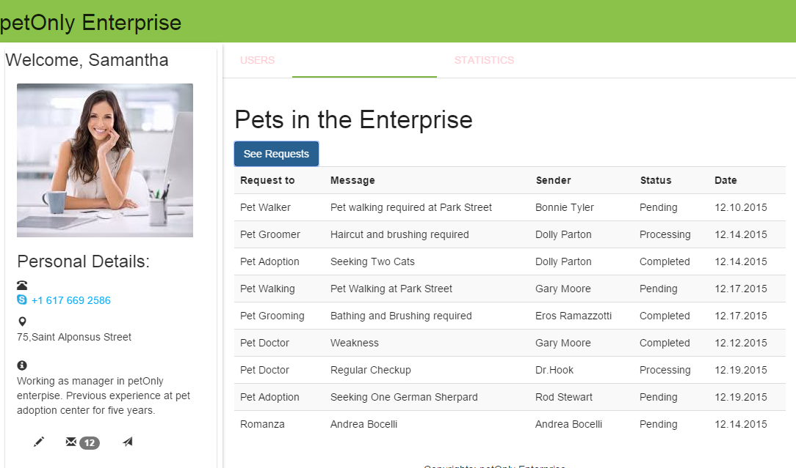

Messages by toggle

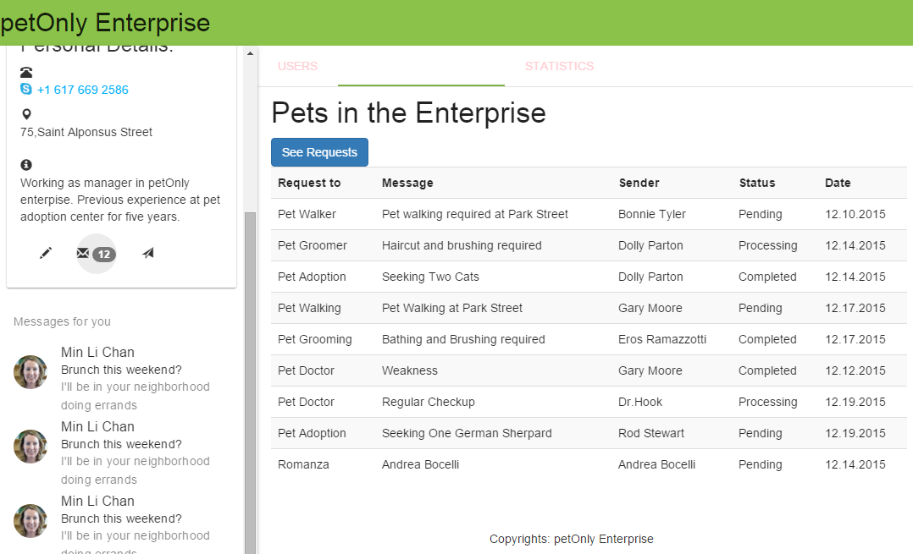

Bootstrap modal

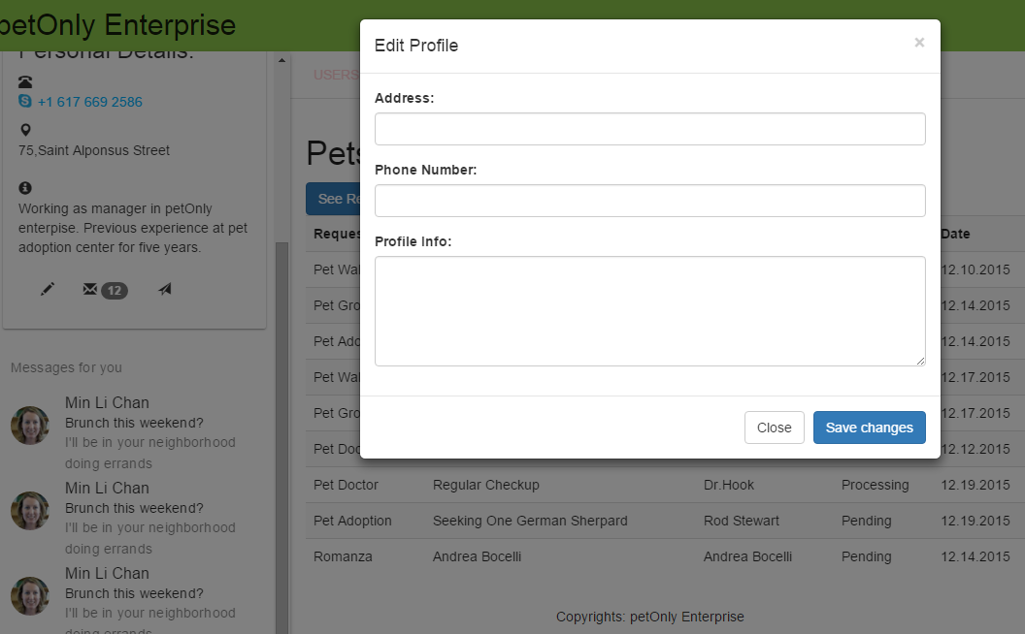

Pet Owner Login

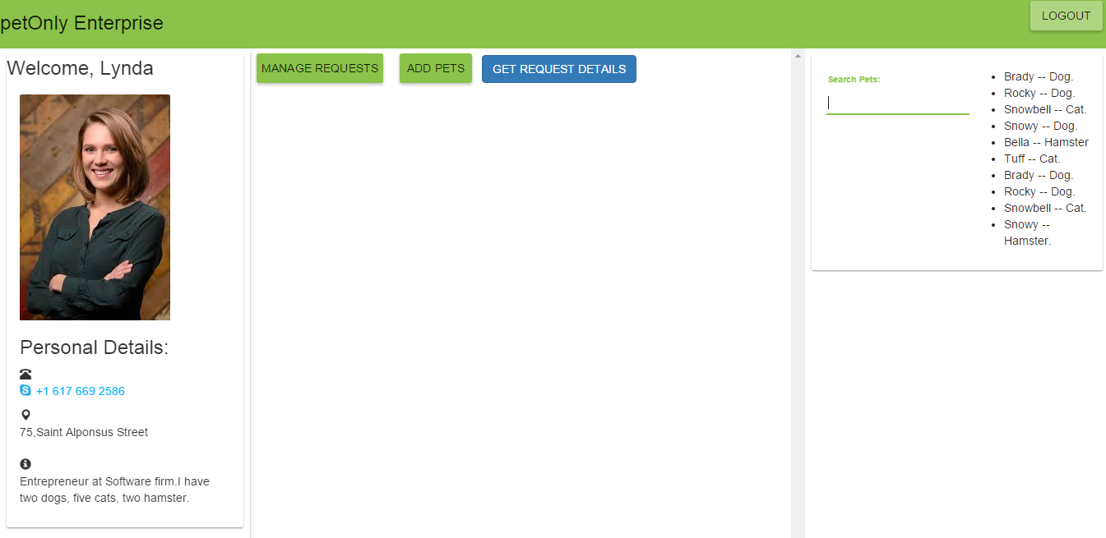

Search feature with filter

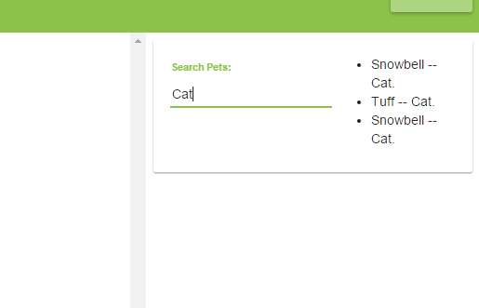

Create Request –with info message.

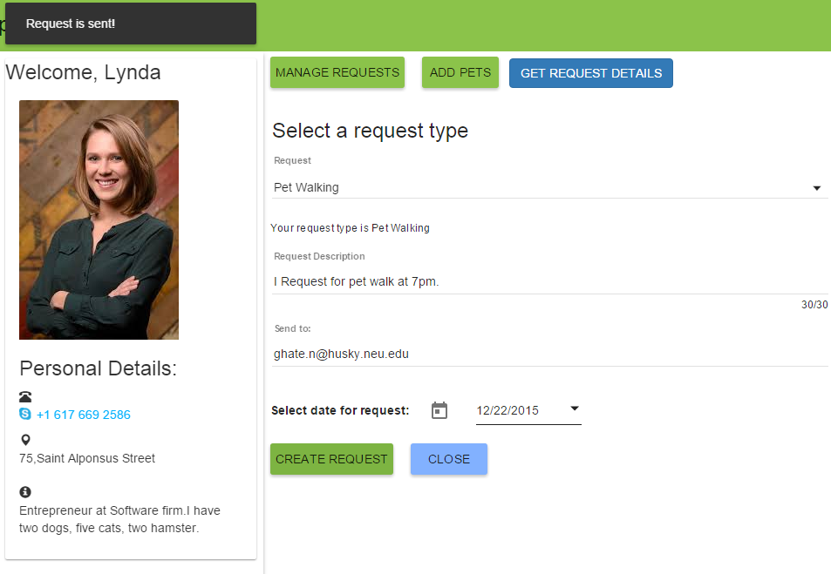

Add Pet

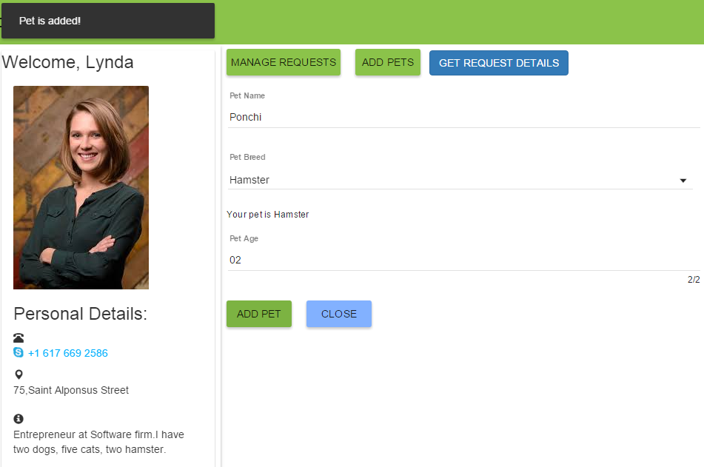

Get Request table by AJAX

